**CHAPTER 1**

**INTRODUCTION**

In the modern era of pharmaceutical drugs which play an indispensable role in the daily life of humans and every individuals across the globes which severs essential functions such as the treatment which manage and prevent a various medical conditions which affects both humans and animals with drug manufacture that ensuring the vital information related to dosage usage and safety of the person and the precautions will take systematically manner and provided on drug labels to guide the consumers in making a informed and responsible medication decisions.

However, the despite availability of such a crucial information’s with the individuals, who are those with visual patients, illiterates and difficult to read small and unclear text, face significant obstacles in comprehending the details which is printed on drug labels which increases and improper medication usage, incorrect dosage and health consequences. To address these challenges the proposed research introduces a novel methodology that cut the edge of the image and text processing techniques to extract, process and present drug-related information in an accessible format, thereby enhancing readability and ensuring the consumers that can accurately interpret the content displayed on drug packaging.

The system operates by capturing drug label images through a mobile device camera followed by a series of image preprocessing techniques such as noise reduction, colour analysis and background removal to optimize the image quality for improved text extraction. Subsequently the Optical Character Recognition (OCR) technology is applied to convert the textual content embedded within the processed image into a machine-readable format which is then refined and analyzed using Natural Language Processing (NLP) techniques to correct errors, normalize text variations and identify relevant drug related details. Finally, the extracted information is transformed into an audio output using Text-to-Speech (TTS) technology, providing users with an accessible and convenient means of obtaining essential drug-related details audibly, ensuring greater clarity, accuracy and usability for individuals who encounter difficulties reading the printed medication labels.

* 1. **BACKGROUND**

Medicine consumption has become a part of daily life for millions of people. However, reading and understanding drug labels remains a challenge, especially for the elderly, visually impaired or individuals with low literacy levels. Drug labels often contain critical information such as the drug name, dosage instructions, expiry date, storage guidelines, and safety warnings. Misreading or ignoring this information can lead to medication errors, which may cause serious health risks or even fatalities.With the growth of artificial intelligence, optical character recognition (OCR) and natural language processing (NLP) it is now possible to create intelligent systems that can extract and analyze text from images.

This technology can be applied to assist users in reading and understanding drug labels accurately and efficiently.The Smart Drug Label Analyzer project aims to develop a software solution that allows users to scan or upload images of drug labels. The system will extract the text using OCR and intelligently identify key pieces of information like dosage, expiry, and warnings. This not only improves medication safety but also empowers users to take control of their own health with better understanding and confidence.By automating the analysis of drug labels, this project contributes to the field of smart healthcare systems, reducing the risks associated with manual reading errors and making drug information more accessible to everyone.

* 1. **PROBLEM DEFINITION**

Drug labels contain essential information such as the medicine name, dosage, expiry date, warnings, and instructions for use. However, this information is often printed in small fonts or complex medical terminology, making it difficult for many users especially the elderly, visually impaired or those with limited literacy or language proficiency to read and understand. Additionally, in rural or low-resource settings, there is often a lack of awareness or guidance on how to interpret drug labels properly. This can lead to medication misuse, such as consuming expired drugs, incorrect dosages, or ignoring critical warnings, potentially causing severe health complications.There is currently no widely available, intelligent, and easy to use tool that can automatically analyze drug labels and present the information in a clear, understandable format to the user.

* 1. **MOTIVATION**

In the modern healthcare landscape, patient safety and medication adherence are critical concerns. Every year, thousands of cases of medication errors are reported globally due to misinterpretation of drug labels. These errors often occur because users are unable to understand the small, complex, or unclear text printed on medicine packaging. The absence of a smart, automated assistant that can help people understand drug labels easily and safely.

With the advancement of technologies such as OCR (Optical Character Recognition), Artificial Intelligence and Natural Language Processing we are now in a position to develop intelligent systems that can bridge this gap. A mobile or desktop solution that can analyze drug labels and provide clear, understandable output can drastically reduce risks, improve health awareness, and support better decision-making in medication usage.

**1.4 OBJECTIVE**

The primary objective of this research is to design and develop an efficient, automated system capable of extracting, processing, and presenting drug label information in an accessible format, thereby improving the usability and comprehension of drug-related details for consumers.

The specific goals of this research include:

* **Developing an Image Processing Pipeline**
* Implementing techniques such as median filtering, colour histogram analysis and background removal to enhance image quality and optimize text recognition.
* Ensuring that the system can effectively process drug labels under varying lighting conditions, image distortions, and font styles.
* **Enhancing Optical Character Recognition (OCR) Accuracy**
* Utilizing OCR technology to accurately extract printed text from drug labels and convert it into machine-readable text.
* Optimizing OCR performance by implementing preprocessing techniques that reduce noise and improve text segmentation.
* **Implementing Natural Language Processing (NLP) for Text Analysis**
* Employing NLP techniques such as tokenization, text normalization and fuzzy string matching to refine extracted text and improve the accuracy of drug information retrieval.
* Identifying key drug attributes, including trade names, active ingredients, instructions, and warnings, to ensure comprehensive data extraction.
* **Developing a Drug Information Search Mechanism**
* Creating a structured drug data file in JSON format for efficient keyword-based searching of drug-related details.
* Implementing a similarity-based retrieval approach to handle variations in drug names and text formatting.
* **Integrating Text-to-Speech (TTS) for Audio Output**
* Converting processed drug information into spoken language using TTS technology to assist individuals with reading difficulties.
* Ensuring that the synthesized speech output maintains clarity, accuracy, and natural-sounding pronunciation for ease of comprehension.
  1. **SCOPE OF THE PROJECT**

The scope of this research encompasses the development, implementation and evaluation of a novel methodology that integrates image processing, optical character recognition (OCR), natural language processing (NLP), and text-to-speech (TTS) techniques to extract and interpret information from drug labels. This study specifically focuses on drug packaging in the form of boxes, blister packs, sachets, or bottles that contain oral drugs available for purchase at retail pharmacies without requiring a prescription. The system is designed to process drug labels captured in image formats such as JPEG, JPG, or PNG, ensuring compatibility with common digital imaging standards.

The research includes various aspects of image enhancement, such as noise reduction, colour histogram analysis, and background removal, to improve text recognition accuracy. Additionally, it involves text extraction and processing techniques to normalize, refine, and retrieve critical drug-related information, including trade names, active ingredients, usage instructions, precautions, and expiration dates.

Furthermore, the study limits its focus to drug labels printed in standardized fonts and clear layouts, as highly distorted, low-resolution, or handwritten labels fall outside the system’s capability. The final output of the system is an audio-based representation of the extracted drug information, ensuring accessibility for individuals with vision impairments or reading difficulties.

**1.6 MODULES AND THEIR DESCRIPTIONS**

The smart drug analyzer system consists of key modules:

* **Image Capture Module**: Accepts images of drug labels in JPEG, JPG, or PNG formats from various drug packaging types and prepares them for processing.
* **Processing Module:** Enhances image quality using techniques like median filtering (noise reduction), color histogram (brightness/contrast adjustment), and background removal to make label text clearer**.**
* **OCR Module**: Uses Optical Character Recognition (OCR) to convert processed images into raw text, capturing essential information from the drug label.

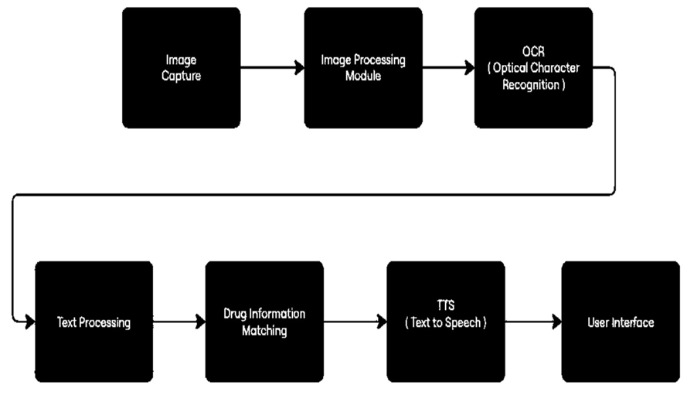

**FIGURE 1.1: MODULE DETAILS**

The figure 1.1 shows that the illustrates the key modules used in the project and how the system operates. A detailed explanation of each key module is provided.

* **Text Processing Module**: Cleans and standardizes extracted text, applies tokenization, normalizes words, and extracts expiration dates with regular expressions for consistency and clarity.
* **Drug Information Matching Module**: Matches processed text with a drug data file using fuzzy string matching to retrieve accurate drug details like name, ingredients and usage.
* **TTS Module**: Converts processed drug information into audio using Text-to- Speech (TTS), enabling users to listen to drug details and expiration dates.
* **User Interface**: User interface which refer to the parts of the application that users can interact with directly.

**CHAPTER 2**

**PROBLEM STATEMENTS**

Patients often face difficulty reading and understanding drug labels due to small font size, complex medical terminology, poor lighting conditions, and lack of accessibility features such as voice or translation support. This issue is particularly significant among elderly individuals, people with low literacy levels, and those with visual impairments. Incorrect interpretation of drug labels can lead to medication errors, resulting in serious health risks such as overdosing, missed doses, or harmful drug interactions.

Despite the availability of OCR and mobile health applications, there is no integrated system that specializes in reading, interpreting, and presenting drug label information in an accessible and user-friendly format. Therefore, there is a critical need for a Smart Drug Label Analyzer that can accurately extract text from drug labels using OCR, interpret medical information through Natural Language Processing (NLP), and present the output through voice, translations, and simple visuals. Such a system should be affordable, mobile-compatible, and usable in real-world environments without requiring expert knowledge.

In recent years, medication-related problems have become a major global health concern, particularly due to incorrect dosage, misunderstood warnings, or expired medications. One of the root causes is poor comprehension of drug labels, which often contain technical language, fine print, and critical information spread across multiple sections.

This issue is amplified in rural areas, among elderly people, and individuals with visual or cognitive impairments, who are unable to understand drug instructions effectively. Moreover, the problem is multilingual in nature, since most labels are printed in only one language—limiting access for non-native speakers.

Despite the availability of OCR and general-purpose mobile readers, no system specializes in the domain of medical text extraction and interpretation, leaving patients at risk of making critical medication mistakes.

Medication labels are a critical source of information for patients. They contain instructions about dosage, frequency, storage conditions, expiry dates, and warnings about side effects or interactions. However, the effectiveness of drug labels is often limited due to:

* Small font sizes that are hard to read, especially for elderly or visually impaired patients.
* Medical jargon that is difficult for non-medical users to understand.
* Multilingual challenges, especially when the patient’s first language is different from the language used on the label.
* Poor lighting or print quality, which affects readability.
* Low literacy levels, which can cause misinterpretation of drug instructions.

These challenges contribute to medication non-adherence, accidental overdoses, and adverse drug interactions, which are a growing concern in healthcare systems worldwide.

While OCR (Optical Character Recognition) and some mobile apps are available, they are mostly general-purpose tools and not tailored for medical or pharmaceutical use. They do not provide intelligent interpretation or assistive outputs such as voice narration, interactive instructions, or real-time drug interaction alerts.

**CHAPTER 3**

**LITERATURE REVIEW**

**3.1 RESEARCH PAPERS**

**3.1.1 Design and Implementation of a Pharmaceutical Inventory Database Management System -S. S. Samaan et al. [2017]**

This paper focuses on inventory management, its structure for organizing pharmaceutical data can be leveraged by a Smart Drug Label Analyzer, especially in Managing recognized drugs and associating them with expiry dates and supplier information. Providing backend support for label validation against a real-time drug database. Structuring outputs from OCR in a relational database for logging and future references.

The system design followed traditional database management principles using **MySQL** as the back-end and **VB.NET (Visual Basic .NET)** as the front-end development tool. The project focused on preventing **stockouts**, **drug expiration**, and **data redundancy**, which are critical challenges in pharmaceutical logistics.

**3.1.2 Smart Drug Delivery Systems using Large Language Models for Real-Time Treatment Personalization- Jagendra Singh et al. [2024]**

Many studies were conducted on the use of AI and ML in healthcare with a focus on personalized medicine. Traditional drug recommendation methods usually rely on the use of clinical guidelines and physician experience, and although their recommendation is highly important, it is hampered by the lack of access to comprehensive patient data and the algorithms required to process it effectively.

Recent advancements in the development and use of artificial intelligence have enabled the use of more complex algorithms that can process data effectively and recommend treatment in a more patient-oriented manner. Recently, deep learning models, particularly those employing neural networks, have been utilized in various healthcare disciplines such as disease diagnosis, prognosis prediction, and treatment prescription.

For example: Convolutional Neural Networks have been extensively utilized in image-related tasks such as medical imaging analysis, while Recurrent Neural Networks are employed in the processing of sequential data such as patient monitoring in healthcare time-series, Nevertheless, some issues hinder the widespread application of these models in clinical settings, including the requirement of a large amount of labeled data and computational capacity. A new NLP paradigm has emerged with the introduction of LLMs. Models like BERT and GPT now outperform the state-of-theart in many NLP tasks.

G. Michelet and F. Breitinger, “ChatGPT, Llama, can you write my report? An experiment on assisted digital forensics reports written using (local) large language models,” Forensic Science International: Digital Investigation, vol. 48, no. March, 2024, doi: 10.1016/j.fsidi.2023.301683.

S. Sellamuthu, S. A. Vaddadi, S. Venkata, H.Petwal, R. Hosur, et al., “AI-based recommendation model for effective decision to maximise ROI”, Soft Computing, pp.1-10, 2023. https://doi.org/10.1007/s00500-023-08731-7.

**3.1.3 Precision Medicine: Applied Concepts of Pharmacogenomics in Patients with Various Diseases and Polypharmacy - V. Michaud and J. Turgeon et al**. **[2021]**

This paper explores how precision medicine where the tailoring of medical treatment to the individual characteristics of each patient—is applied in real-world scenarios using pharmacogenomics. Pharmacogenomics is the study of how a person’s genetic makeup affects their response to drugs. In patients with multiple diseases (comorbidities) and those on polypharmacy (taking multiple medications), drug interactions and side effects are common. The paper discusses how genetic variations in enzymes like CYP2D6, CYP2C19, and others impact drug metabolism and influence.

The development of a Smart Drug System in the pharmaceutical industry relies on integrating diverse technologies such as Optical Character Recognition (OCR), Natural Language Processing (NLP), drug databases, and pharmacogenomics. Prior research and implementations have laid foundational work in each of these domains.

|  |  |  |  |  |  |  |
| --- | --- | --- | --- | --- | --- | --- |
| **SERIAL NUMBER** | **PAPER TITTLE**  **& PUBLICATION DETAILS** | **NAME OF THE AUTHORS** | **TECHNICAL IDEAS / ALGORITHMS USED IN THE PAPER &**  **ADVANTAGES** | | | **SHORTFALLS/DISA DVANTAGES & SOLUTION PROVIDED BY THE PROPOSED**  **SYSTEM** |
| 01 | Image Processing for OCR in Drug Labels (2016) | S. Suntron suk et al. | Preprocessing techniques like binarization and median filtering to improve OCR accuracy. Advantage: Enhanced image  clarity and text readability | | | Shortfall: Limited support for noisy images with irregular fonts. Solution: Incorporating background removal and contrast adjustments |
| 02 | OCR and Machine Learning for Drug Labels (2020) | X. Liu et al. | Deep learning- enhanced OCR for text extraction.  Advantage: High accuracy in recognizing drug label  content. | | | Shortfall: High computational cost. Solution: Using lightweight OCR models for mobile devices. |
| 03 | NLP Techniques in Text Standardization n (2020) | C. Suthpin et al | NLP methods like tokenization and normalization to improve text consistency.  Advantage: Accurate identification of critical information  like warnings. | | | Shortfall: Difficulty in handling multilingual text. Solution: Adding multilingual translation support. |
| 04 | Text-to-Speech for Accessibility (2019) | Google Research | Use of TTS for reading out text.  Advantage: Accessibility for  visually impaired users. | | | Shortfall: Limited language support. Solution: Multilingual audio output. |
| 05 | Improving smart medication management  (2021) | H.-Y. Cheng et al. | | Improving smart medication management | Shortfall: Limited language support. Solution: Multilingual audio output. | |
| 06 | How smart  medication systems are used to support older people's drug  regimens: A systematic literature review | R. Turjamaa et al. | | Systems must be non-intrusive  Minimal learning curve. Accurate Drug Identification  Medication Safety: | Shortfall: Difficulty in handling multilingual text. Solution: Adding multilingual translation support | |
| 07 | Design and Implementation of Automated  Drugs Mixer, | B. Hayder Ajmi and A. Ahmed Rashid et al. | | Reduces human error in critical drug mixing.  Limits exposure to toxic compounds. Faster preparation for emergency or high-volume scenarios. | Shortfall: Lack of Real-Time Drug Identification.  Solution: Lack of Real-Time Drug Identification | |
| 08 | Improving Diabetic Patients  Monitoring System Using (NCA-CNN) Algorithm based on loT | M. Ayas Talib et al. | | Manual monitoring delays. Data overload from raw sensor input | Shortfall: High Cost of IoT Devices.  Solution:Low-Cost IoT Integration | |
|  |  |  | |  |  | |
| 09 | Large Language Model Based Fake News Detection | M. Aman et al. | | High Accuracy & Contextual Understanding | Shortfall: Data Bias and Fairness Issues.  Solution: Reduce Computational Cost | |
| 10 | Large Language Model Based Fake News Detection | M. Sajid et al. | | High Contextual Understanding & Automatic Feature Extraction | Shortfall: Bias in Training Data.  Solutions: Reduce Computational Load. | |

The **Dosage Label Analyzer** integrates multiple proven technologies like OCR, NLP, translation, TTS, and AI-based interaction checker to create an intelligent system that enhances the readability, understanding, and safety of drug dosage instructions. This system addresses key challenges in multilingualism, accessibility, and patient safety in medication adherence.

OCR is used to extract printed text from drug labels. Tesseract.js is a popular open-source tool for this purpose in healthcare applications. NLP helps with interpret medical text such as dosage, frequency, and warnings. AI tools like Google Gemini assist in summarizing complex drug instructions.

Machine translates dosage information into multiple languages (e.g., Hindi, Kannada, Tamil, Telugu), improving accessibility and understanding for diverse users. Text-to-Speech  
reads out the extracted dosage information, helping visually impaired or elderly patients understand drug instructions clearly. Drug interaction checker AI tools check if the extracted drugs interact harmfully with others. This improves medication safety by preventing adverse drug combinations.

**CHAPTER 4**

**PROPOSED METHODOLOGY**

The Dose Sense Analyzer is designed to simplify the understanding of complex drug usage labels using a combination of OCR (Optical Character Recognition), AI-based summarization, multilingual translation, and speech synthesis technologies. The methodology follows a modular, pipeline-based architecture where each step builds on the previous one to enhance the drug label’s accessibility and interpretability.

The Dose Sense Analyzer is an intelligent web-based tool designed to interpret and simplify complex drug labels. The system primarily aims to assist patients, pharmacists, and healthcare professionals by converting medical jargon into understandable, localized, and spoken formats. This is achieved through a pipeline of integrated technologies involving Optical Character Recognition (OCR), generative AI interpretation, multilingual translation, voice synthesis, and interaction checking.

The system processes it through the following interconnected stages:

* **Image Input (File Upload)**

The user initiates the process by uploading an image of a drug label or medical instruction slip through a stylized and interactive UI component. The interface accepts standard image formats (JPEG, PNG, etc.) and provides immediate visual feedback to ensure correct image selection.

* **Text Extraction (OCR using Tesseract.js)**

Once the image is uploaded, it is processed using **Tesseract.js**, a powerful JavaScript-based OCR engine. This module scans and extracts printed text from the image. It detects and preserves layout, fonts, and line breaks to improve interpretation accuracy in later stages.

* **AI-Powered Interpretation (Gemini AI)**

The raw text extracted by OCR often includes technical language, dosage instructions, warnings, and compound names. To simplify this, the text is analyzed using **Gemini AI**—a generative language model developed by Google. The AI processes the content and delivers a clear, human-like summary.

* **Multilingual Translation (My Memory API)**

To make the system more inclusive, the AI-generated summary is passed to the My Memory Translation API, allowing it to be translated into multiple Indian languages such as Kannada, Hindi, Tamil, Telugu, and English. This ensures that users from different linguistic backgrounds can comprehend critical health instructions.

### **Text-to-Speech Synthesis**

### Once translated, the text is read aloud using the browser’s built-in **speech synthesis API.** This is particularly beneficial for the Visually impaired users especially for the elderly individuals who prefer hearing over reading and users with limited literacy.

* **Drug Interaction Checking**

This critical module uses AI to check for potential **drug-drug interactions**, allergic compounds, or medical contradictions. The system parses the AI-interpreted summary and searches for common dangerous combinations or usage warnings using a predefined dataset and AI-enhanced.

* **Report Generation & Download**

Finally, the system compiles all processed data into a structured, downloadable PDF report. This report includes:

* Original extracted text
* AI-simplified instructions
* Translations
* Interaction warnings (if any)
  1. **KEY ADVANTAGES OF PROPOSED METHODOLOGY**
* Seamless pipeline from image to intelligent output.
* No backend operations needed to run on client-side and cloud APIs.
* Highly user-friendly interface with audio output.
* Real-time translation and interpretation.
* Helps low-iterate and non-English speakers understand medical labels.
  1. **DATAFLOW DIAGRAM**

**AI Interpretation**

**OCR Extraction**

# **Upload Image**

# **User**

**Translation**

**Text-to-Speech**

**Interaction**

**Report Export**

The Dose Sense Label Analyzer system processes a drug label image through a structured data flow involving multiple components. The process begins when a user uploads a drug label image, which initiates the primary data flow. The image is passed to the OCR (Optical Character Recognition) module, specifically powered by Tesseract.js, which extracts textual content from the label and stores it in a temporary text data store.

This raw text is then sent to the AI interpretation module, where Gemini AI analyzes the extracted content to generate a simplified, human-readable summary explaining dosage, warnings, usage instructions, and side effects. The AI summary is stored in a structured format and forwarded to the translation module, which utilizes the My Memory API to translate the summary into multiple regional languages, such as Kannada, Hindi, Tamil, Telugu, and English. The translated content is both displayed to the user and routed to the text-to-speech synthesis module, where the Speech Synthesis API converts the text into spoken audio in the selected language, making the system accessible to users with visual or literacy challenges.

Parallel to this, the system performs a drug interaction check, scanning the AI-interpreted content for potential conflicts or harmful drug combinations using internal rules or AI prompts. Once all modules have processed the data, the system aggregates the original OCR text, AI summary, translated outputs, and interaction results into a well-structured PDF report, which the user can download for offline use.

Throughout this process, multiple temporary data stores are used to hold intermediary outputs for smooth transition between stages, ensuring seamless data flow and real-time interaction. This entire pipeline emphasizes user accessibility, safety through drug checks, and multilingual communication, ultimately forming a robust, intelligent medication label analysis system.

**CHAPTER 5**

**REQUIREMENT ANALYSIS**

**5.1 FUNCTIONAL REQUIREMENTS**

* **Image Capture:**

The system must enable users to upload or capture images of drug labels in standard formats such as JPEG, JPG, or PNG. This ensures compatibility with a wide range of devices and image sources, including photos taken with mobile phones or images scanned from packaging.

* **Image Processing:**

Advanced image processing techniques should be implemented to enhance image quality and improve text readability for OCR (Optical Character Recognition). These include:

* Median filtering for noise reduction.
* Brightness and contrast adjustment to handle varying lighting conditions.
* Background removal to isolate the text from complex or distracting backgrounds.

This preprocessing step ensures the system can accurately extract information even from poorly captured images.

* **OCR Module:**

The OCR module is responsible for converting processed images into digital text. Using Tesseract OCR, the system identifies and extracts essential drug label details, such as:

* Drug name and Usage
* Ingredients
* Expiration date

The OCR module is optimized for accuracy in text detection and can handle various fonts, sizes, and orientations commonly found on drug labels.

* **Text Processing:**

The extracted text undergoes standardization and cleaning to ensure consistency and usability. Techniques include:

* Tokenization to divide the text into meaningful units.
* Normalization to correct irregularities such as abbreviations or typographical errors.
* Regular expressions to extract structured data such as expiration dates and dosage information
* **Drug Information Retrieval:**

The system matches the cleaned and processed text with a pre-stored drug database. Using fuzzy string matching, the system retrieves accurate drug details even if there are minor variations or errors in the OCR output. The retrieved information includes:

* + - Drug name
    - Ingredients
    - Usage
    - Side effects
    - Storage instructions

### **Text-to-Speech (TTS):**

To enhance accessibility, the system converts the extracted drug information into speech using the Google Text-to-Speech API. This feature is particularly beneficial for visually impaired users, allowing them to listen to detailed drug information, including pronunciation support for complex medical terms.

## **NON-FUNCTIONAL REQUIREMENTS**

* + - **Performance:** The system should process an image and retrieve drug information within 5 seconds to ensure a fast and efficient user experience.
    - **Accuracy:** The OCR and data matching processes must achieve a minimum of 90% accuracy to ensure reliable information retrieval.
    - **Scalability:** The system should support additional languages for translation and handle an expanding database of drug labels.
    - **Accessibility:** A user-friendly interface with features like larger buttons, audio feedback, and minimal navigation steps enhances usability for all users, including those with disabilities.
    - **Security:** User data, especially when utilizing cloud-based OCR and TTS services, must be protected through encryption. The system should comply with data privacy regulations to ensure secure handling of sensitive information.
  1. **SOFTWARE REQUIREMENTS**
* **Operating System:**
* Android 7 (Nougat) or higher for mobile deployment.
* Windows 10, macOS, or Linux for development and testing.
* **Development Tools:**
* Android Studio for app creation, debugging, and testing.
* **Programming Languages:**
* Java for application logic and XML for UI design.
* **Libraries/Frameworks:**
* Tesseract OCR for extracting text from images.
* Google Text-to-Speech API for converting text to audio.
* TensorFlow Lite for optional machine learning features (e.g., enhanced text detection or predictive matching).

## **HARDWARE REQUIREMENTS**

## **Processor:** Minimum quad-core processor (e.g., Snapdragon 400 series for mobile devices or Intel i3 for desktops). Higher-tier processors recommended for better performance.

## **RAM:** At least 4 GB (8 GB recommended for smoother performance and faster image processing)

* **Camera (Mobile):** Minimum resolution of 8 MP (12 MP or higher with autofocus recommended for accurate OCR results)
* **Storage:** At least 200 MB for installation (1 GB recommended for caching images and storing the drug database locally)
* **Internet Connectivity:** Required for cloud-based OCR and TTS services. Offline processing options should be included for scenarios with limited connectivity.

## **TECHNOLOGIES USED**

### **Image Processing:** Median filtering to reduce noise. Brightness and contrast adjustments for better visibility. Background removal to enhance text isolation**.**

### **OCR (Optical Character Recognition):** Tesseract OCR for converting text from images into digital format. Supports multiple languages and diverse text styles/orientations**.**

### **Natural Language Processing (NLP):** Tokenization and normalization for consistent and interpretable text. Identification and extraction of key information such as expiration dates, dosages, and ingredients**.**

### **Multilingual Support:** Translation capabilities for drug information into 1-2 additional languages, ensuring accessibility for non-English speakers.

**CHAPTER 6**

**SYSTEM DESIGN**

## **MODULES AND COMPONENTS**

### **Image Processing Module:** This module enhances the quality of the captured drug label images before performing text extraction.

### **Optical Character Recognition (OCR) Module:** This module extracts text from the processed drug label image.

### **Natural Language Processing (NLP) and Text Processing Module:** This module refines and structures the extracted text for improved accuracy in drug information retrieval.

### **Drug Information Retrieval Module:** This module searches for drug-related details in a structured drug database.

### **Expiration Date Detection Module:** This module extracts and verifies expiration dates from drug labels.

### **UML DIAGRAMS**

The UML (Unified Modelling Language) diagram represents the structural and behavioral aspects of the system. It includes various diagrams such as class, sequence, and activity diagrams, each serving a specific purpose. The class diagram defines the system’s key components, including classes like *Camera, Image Processing, OCR, Text Processing, TTS,* and *Display*, along with their attributes and methods. The sequence diagram illustrates the interaction flow between different system components, from image capture to text extraction, processing, and output generation. The activity diagram represents the workflow, starting from user input, permission handling, image preview, vision API processing, result extraction, and optional translation or text-to-speech conversion.

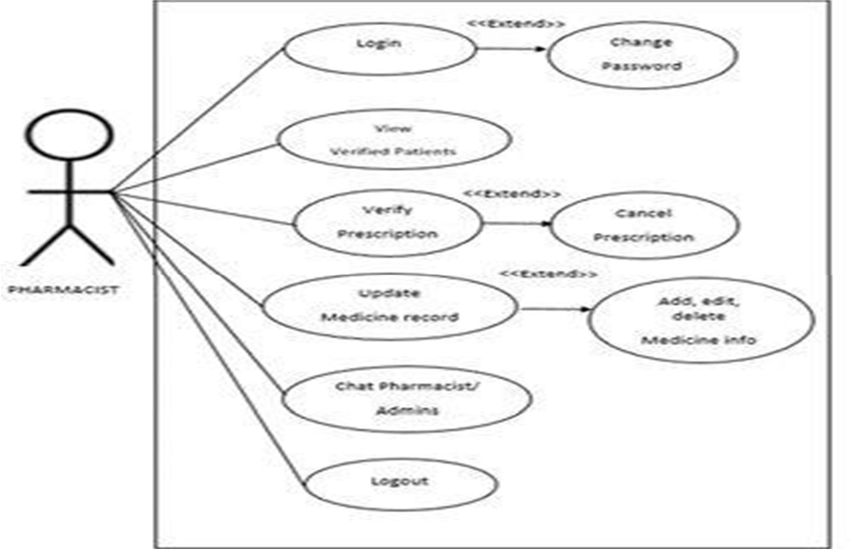

### **Figure 6.1: USE CASE DIAGRAM OF USER**

The figure 6.1 shows that the case diagram of user which consists of UML diagrams collectively provide a use case diagramwhich consists of UML diagram represents the different components and their interactions in the system. Below is a Use Case Diagram describing the key processes in drug label information extraction.

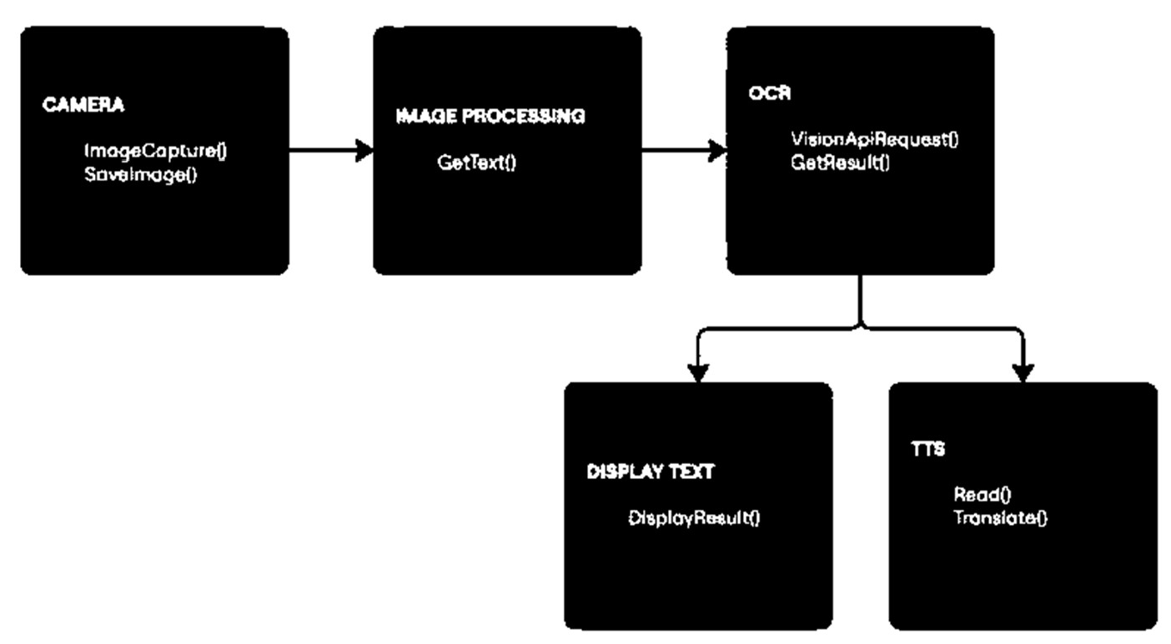

**Figure 6.2: CLASS DIAGRAM**

The figure 6.2 shows thatthe class diagram which represents the structure of the smart drug label analyzer system, showcasing its main components and their interactions. The Cameraclass is responsible for capturing and saving images of drug labels. The Image Processingclass extracts text from the image using functions like GetText (), ensuring clarity and readability.

* 1. **SYSTEM ARCHITECTURE**

The System Architecture of the *Dosage Sense Label Analyzer* follows a modular, layered design that integrates web technologies with AI and cloud-based services to perform intelligent drug label interpretation. We can see that at the top level, the User Interface (UI) is built using HTML, Tailwind CSS, and JavaScript, providing an interactive front-end for users to upload images, receive translations, listen to audio, and download reports.

In the Input Layer the figure 6.3 shows that at starting we have to upload image mechanism where the user selects a drug label image using a custom-styled file input box. This image is sent to the OCR Layer, where Tesseract.js (a JavaScript-based OCR engine) converts the image into raw text. The text then flows into the AI Interpretation Layer, which connects to Gemini AI (Google Generative AI).

This layer semantically analyzes the content and extracts meaningful interpretations such as the drug’s name, dosage, usage, and warnings. Once interpreted, the data flows to the Translation Layer, where the My Memory Translation API handles multilingual translation into user-selected languages including Hindi, Kannada, Tamil, Telugu, and English. Simultaneously, the Text-to-Speech Layer leverages the browser's Speech Synthesis API, dynamically selecting an appropriate voice (e.g., hi-IN for Indian languages) to speak out the translated output.

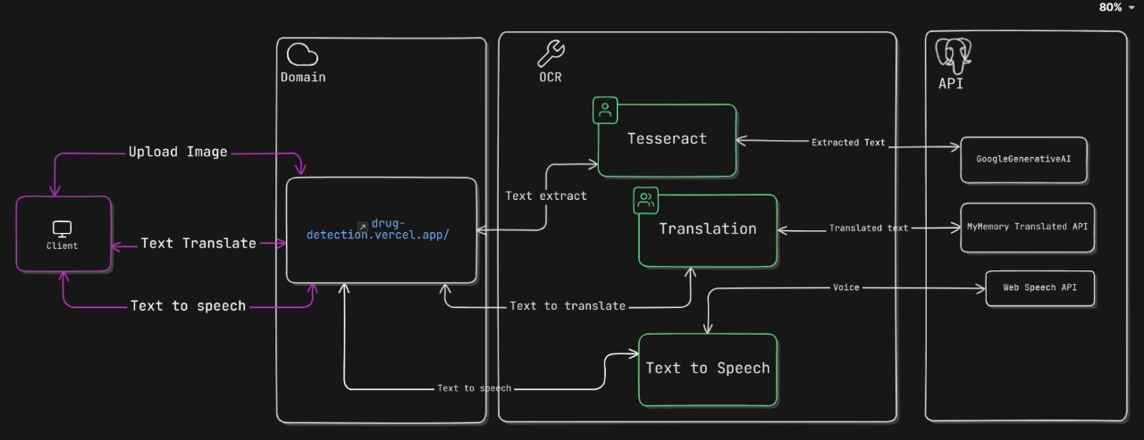

**Figure 6.3: SYSTEM ARCHITECTURE**

In the Interaction Checker Layer, the AI is reused to evaluate if the extracted drug has harmful interactions with any other drug input by the user. All outputs OCR text, interpretation, translation, interaction results are passed into the Report Generation Layer, where the content is formatted and provided as a downloadable text report. Each layer communicates via JavaScript events and promises, ensuring a smooth flow of data between components. This architecture is entirely client-side, making it lightweight and browser-compatible, with APIs like Tesseract.js and Gemini AI performing the heavy lifting. Additionally, the architecture supports scalability for future features like voice input, offline mode, or integration with medical databases. This layered and modular architecture ensures separation of concerns, easy debugging, real-time performance, and an intuitive user experience for drug safety awareness.

**CHAPTER 7**

**IMPLEMENTATION**

## **7.1 DEVELOPMENT PROCESS**

The system was developed iteratively using deep learning and web technologies, Optical Character Recognition and security protocols for safe image processing.

* **Image Capture Module:** Code snippet to upload or capture an image using the camera interface.
* **Image Processing Module:** Implementation of median filtering and contrast adjustment using OpenCV or similar libraries.
* **OCR Module:** Code using Tesseract OCR to extract text. /Cloud vision API Text.
* **Processing Module:** NLP code for tokenization and normalization. Drug Information.
* **Retrieval Module:** Fuzzy string-matching code to retrieve drug details.
* **TTS Module:** Implementation using Google Text-to-Speech API for audio output.
* **Interaction Checker:**It is a tool, often used online, that helps identify potential interactions between medications, food, supplements, or medical conditions

### **Project Implementation Technology:**

The system uses Tesseract OCR to extract text, and HTML/CSS/JavaScript for the front end. Fuzzy string-matching code to retrieve drug details, while Google Text-to-Speech API for audio output. Data augmentation enhances model accuracy, and security protocols ensure safe image processing.

* Hardware Requirement:
* Processor –Core i5
* Hard Disk – 160 GB
* Memory – 1GB RAM
* Monitor

### Software Requirement:

* Windows 7 or higher
* Html/css/js
* Tesseract OCR

## **7.2** **OVERVIEW OF TECHNOLOGIES USED**

## **7.2.1 HTML (Hypertext Markup Language)**

HTML serves as the backbone of every webpage on the internet, providing the essential structure and layout. It is a markup language that uses tags to define different elements on the page. HTML structures content such as headings, paragraphs, lists, forms, images, and links, and forms the skeleton of web pages. By using HTML, developers can create headings using <h1>, <h2>, etc., to represent the importance of different sections of the content, paragraphs using <p>, and lists with <ul> (unordered list) or <ol> (ordered list) tags. One of the most essential features of HTML is the <a> tag, which is used to create hyperlinks.

### **7.2.2 CSS (Cascading Style Sheets)**

CSS is the language used to style and lay out HTML elements, turning a basic webpage into an attractive, visually appealing design. It controls the presentation, layout, and overall look and feel of a website by specifying styles for individual HTML elements or groups of elements. The power of CSS lies in its ability to define how elements should be displayed, using properties such as colors, fonts, borders, margins, padding, and more. CSS selectors allow developers to target HTML elements in a flexible way, whether by class, id, or tag name, and apply styles accordingly. One of the standout features of CSS is its ability to manage the layout of a page. Through the power of CSS, developers can ensure that web pages are not only functional but visually attractive and user-friendly.

### **7.2.3 JavaScript (JS)**

JavaScript is the scripting language that adds interactivity and dynamic behaviour to a webpage, enabling it to respond to user actions in real-time. While HTML gives the structure and CSS controls the presentation, JavaScript makes websites functional and engaging by enabling real- time updates and interactions without the need to reload the page JavaScript also comes with a rich ecosystem of libraries and frameworks, such as jQuery, React, Vue.js, and Angular, which simplify complex development tasks, enhance productivity, and help in building large-scale applications with more maintainable code.

JavaScript's ability to handle both simple tasks (like form validation) and complex functionalities (like building web applications with real-time updates) makes it a vital language in modern web development.

### **7.3 FEATURES OF HTML/CSS/JAVASCRIPT**

* **HTML (Hypertext Markup Language)**
* **Structure:** Defines the structure of a webpage with elements like headings, paragraphs and lists.
* **Semantic Tags:** Uses tags like <article>, <section> and <footer> to enhance meaning and accessibility.
* **Forms:** Allows user input with <form>, <input> and <textarea>.
* **Links:** Creates hyperlinks with the <a> tag for navigation.
* **Multimedia:** Embeds images, audio, and video with <img>, <audio> and <video>.
* **Metadata:** Includes document information with <meta> and <title> tags.
* **Accessibility:** Enhances accessibility with proper structure and alternative text for images.
* **CSS (Cascading Style Sheets)**
* **Styling:** Controls the look and feel of HTML elements, such as colors, fonts, and spacing.
* **Layouts:** Uses Flexbox and CSS Grid for flexible and complex page layouts.
* **Responsive Design:** Makes pages adaptable to different screen sizes using media queries.
* **Positioning:** Allows precise placement of elements with position, float, and z-index.
* **Animations and Transitions:** Provides animations and smooth transitions for interactive elements.
* **Selectors:** Targets elements with class, id, and attribute selectors for efficient styling.

### **JavaScript (JS)**

* **Interactivity:** Enables real-time response to user actions like clicks and keyboard input.
* **DOM Manipulation:** Dynamically changes HTML and CSS content using the DOM.
* **Asynchronous Programming:** Handles background tasks like data fetching without blocking the page.
* **Validation:** Performs client-side validation on user inputs before form submission.
* **Functions:** Supports reusable functions and manages variable scope.
* **Error Handling:** Manages runtime errors with try/catch and custom error handling.

### **JSON documentation:**

* **Data Interchange Format:** JSON is a lightweight, text-based format used to represent structured data in a readable and easy-to-understand way.
* **Human-Readable:** JSON is simple and easy for humans to read and write, making it a popular format for data exchange between systems.
* **Key-Value Pairs:** Data in JSON is represented as key-value pairs, where each key is a string and the value can be a string, number, array, boolean, object, or null.
* **Self-Descriptive:** The keys in JSON are descriptive and help understand the meaning of the data they represent (e.g., "name", "age").
* **Widely Used:** JSON is commonly used for data exchange between web clients (browser) and servers (APIs), especially in RESTful APIs.
* **Language Agnostic:** Although based on JavaScript, JSON is language-independent and supported by most programming languages (Python, Java, PHP, etc.).
* **Easy to Parse:** JSON is easy to parse and generate with built-in libraries in most programming languages.

For example, JavaScript uses JSON.parse() and JSON.stringify() to parse and convert data.

### **7.4 FEATURES OF JSON**

1. **Lightweight:** JSON is a compact format, making it efficient for transmitting data over networks. It doesn't include any extra overhead, unlike other data formats like XML, which makes it ideal for applications requiring fast data exchange.
2. **Human-readable:** JSON is easy for humans to read and write. Its simple, text-based structure with clear formatting helps developers understand and work with data without any complex parsing.
3. **Key-value pairs:** Data in JSON is represented as key-value pairs, where each key is a string (e.g., "name") and the value can be a string, number, boolean, object, array, or null. This structure helps represent data in a logical, accessible way.
4. **Supports multiple data types:** JSON can represent a variety of data types, including strings, numbers, Booleans, arrays, objects, and null values, allowing it to model a wide range of data structures.
5. **Self-descriptive:** JSON keys are descriptive and help provide context to the data they represent. For example, a key like "age" clearly indicates that the value represents an individual's age.
6. **Language-independent:** Although JSON originated from JavaScript, it is a language-independent format. JSON is widely supported across various programming languages such as Python, Java, PHP, and Ruby, making it easy to integrate with different systems.
7. **Easy to parse and generate:** JSON can be easily parsed and generated by most programming languages. Built-in functions like JSON.parse() in JavaScript and json.loads() in Python make handling JSON data straightforward.
8. **Supports nested structures:** JSON allows nested objects and arrays, enabling the representation of complex hierarchical data. For example, an object can contain other objects or arrays, making it versatile for modelling real-world data.
9. **Flexible and dynamic:** JSON does not require a predefined schema, which allows for dynamic data representation. You can add or remove keys from JSON objects as needed without affecting the entire structure.
10. **Widely supported:** JSON is supported by almost all modern web technologies and databases, including RESTful APIs, NoSQL databases (e.g., MongoDB), and front-end frameworks, making it a standard.
11. **TESSERACT:** Tesseractis an open-source optical character recognition engine developed by Hewlett- Packard and later maintained by Google. It supports multiple languages and can be integrated into various applications.

### **7.5 KEY FEATURES OF TESSERACT OCR**

* **Multiple Language Support:** Tesseract OCR is capable of recognizing text in over 100 languages. It also allows users to train new languages and character sets, making it highly adaptable for diverse text recognition tasks.
* **Preprocessing and Image Enhancement:** Tesseract OCR is capable of recognizing text in over 100 languages. It also allows users to train new languages and character sets, making it highly adaptable for diverse text recognition tasks.
* **Cloud-based speech synthesis:** The **Google Text-to-Speech API** is a cloud-based service that converts text into natural- sounding speech. It leverages advanced deep learning models to enhance speech clarity and pronunciation.

### **KEY FEATURES OF GOOGLE TEXT-TO-SPEECH API**

* **Support for Multiple Languages and Voices:** The API supports over 220 voices across more than 40 languages and variants. Users can choose from a range of male, female, and even neural network-powered voices to suit their applications.
* **SSML and Customization Option:** The API allows the use of Speech Synthesis Markup Language (SSML) to fine-tune speech output. Users can control pitch, speed, volume, and pronunciation for a more personalized listening experience.

### **Integration with Various Applications:** Google Text-to-Speech can be easily integrated into mobile apps, web applications, and IoT devices. It is commonly used in accessibility tools, virtual assistants, and automated customer service systems.

### **Multiple Output Formats:** The API generates speech in different formats, including MP3 and LINEAR16, to accommodate various use cases. This flexibility makes it suitable for applications requiring high-quality voice output for different devices and platforms.

## **CHALLENGES FACED**

* Drug labels come in various forms, sizes, and conditions, often leading to challenges in image processing.
* Some drug labels contain handwritten or stylized text, which standard OCR models struggle to recognize.
* Drug labels may include text in multiple languages, requiring the system to handle different scripts, special characters, and language-specific nuances.
* The accuracy of drug detection depends on the availability of reliable datasets. Incomplete or outdated drug databases can lead to incorrect information retrieval, affecting the reliability of the system.
* Smooth integration of the frontend and backend for image uploads and model predictions.

**7.7.1 Feasibility Report:**

Feasibility Study is a high-level capsule version of the entire process intended to answer a number of questions like: What is the problem? Is there any feasible solution to the given problem? Is the problem even worth solving? Feasibility study is conducted once the problem clearly understood. Feasibility study is necessary to determine that the proposed system is Feasible by considering the technical, Operational, and Economical factors. By having a detailed feasibility study the management will have a clear-cut view of the proposed system. The following feasibilities are considered for the project in order to ensure that the project is variable and it does not have any major obstructions. Feasibility study encompasses the following things:

* Technical Feasibility
* Economic Feasibility
* Operational Feasibility
* **Technical Feasibility:** In this step, we verify whether the proposed systems are technically feasible or not. i.e., all the technologies required to develop the system are available readily or not. Technical Feasibility determines whether the organization has the technology and skills necessary to carry out the project and how this should be obtained. The system can be feasible because of the following grounds:
* All necessary technology exists to develop the system.
* This system is too flexible and it can be expanded further.
* This system can give guarantees of accuracy, ease of use, reliability and the data security.
* This system can give instant response to inquire. Our project is technically feasible because, all the technology needed for our project is readily available.

**Operating System :** Windows 7 or above

**Languages :** HTML/CSS/JS

**Documentation Tool :** MS – Word

* **Economic Feasibility:** Economically, this project is completely feasible because it requires no extra financial investment and with respect to time, it’s completely possible to complete this project in 6 months. In this step, we verify which proposal is more economical. We compare the financial benefits of the new system with the investment. The new system is economically feasible only when the financial benefits are more than the investments and expenditure. Economic Feasibility determines whether the project goal can be within the resource limits allocated to it or not. It must determine whether it is worthwhile to process with the entire project or whether the benefits obtained from the new system are not worth the costs. Financial benefits must be equal or exceed the costs. In this issue, we should consider:
  + - The cost to conduct a full system investigation.
    - The cost of h/w and s/w for the class of application being considered.
    - The development tool.
    - The cost of maintenance etc...

Our project is economically feasible because the cost of development is very minimal when compared to financial benefits of the application.

* **Operational Feasibility:** In this step, we verify different operational factors of the proposed systems like man-power, time etc., whichever solution uses less operational resources, is the best operationally feasible solution. The solution should also be operationally possible to implement. Operational Feasibility determines if the proposed system satisfied user objectives could be fitted into the current system operation.
  + - The methods of processing and presentation are completely accepted by the clients since they can meet all user requirements.
    - The clients have been involved in the planning and development of the system.
    - The proposed system will not cause any problem under any circumstances.

Our project is operationally feasible because the time requirements and personnel requirements are satisfied. We are a team of four members and we worked on this project for three working months.

**CHAPTER 8**

**TEST CASES**

Testing is a crucial phase in the software development lifecycle that ensures the final product is reliable, performs as expected, and meets user requirements. The Dose Sense Analyzer underwent several levels of testing including unit testing, integration testing, performance testing, and user acceptance testing (UAT) to validate its core features like OCR, translation, speech synthesis, and drug interaction checking.

The new system has been tested well with the help of the users and all the applications have been verified from every nook and corner of the user. Although some applications were found to be erroneous these applications have been corrected before being implemented. The flow of the forms has been found to be very much in accordance with the actual flow of data.

The steps involved in Testing are:

* **Unit Testing:** Unit testing focuses on verifying the individual components of the system, ensuring each part works as expected. This includes testing the image upload functionality, the prediction model, and various UI elements like buttons or input forms. While manual checks can be employed for frontend validation. The goal is to confirm that small components are functioning correctly before integrating them into the complete system.
* **Integration Testing:** Integration testing aims to validate the interaction between the frontend (HTML, CSS, JavaScript) and API. This ensures smooth communication between the user interface and the backend model. For example, testing whether an image is uploaded correct.
* **Functional Testing:** Functional testing is concerned with ensuring that the application functions according to the defined requirements. This involves testing features like image upload, file format validation, real-time detection, and the accuracy of the model’s predictions. Manual testing or automated tools like Selenium can be used to simulate user interactions and validate that the features work as intended.
* **Performance Testing:** Performance testing assesses how well the system performs under different conditions, such as handling large image files or multiple simultaneous users. The goal is to ensure that response times for predictions are acceptable and that the system can handle real-time detection without lag. Tools like Apache JMeter or Locust are typically used to simulate different load conditions and measure the system’s performance under stress.
* **Usability Testing:** Usability testing evaluates the overall user experience and interface design. This testing ensures the application is easy to use, intuitive, and accessible. Testing focuses on whether users can easily navigate the platform, understand how to upload images, and interpret prediction results.
* **Security Testing:** Security testing ensures that the application is secure from potential vulnerabilities. This includes validating the data protection mechanisms, ensuring that images and user data are handled securely, and testing the image upload functionality to prevent malicious attacks. Tools like OWASP ZAP or Burp Suite can be used to conduct penetration testing and vulnerability scans.
* **Compatibility Testing:** Compatibility testing is essential to ensure that the skin cancer detection application works across different browsers, devices, and operating systems. This type of testing checks if the system functions properly on browsers like Chrome, Firefox, and Safari, as well as on different devices, including smartphones, tablets, and desktops. Tools like Browser Stack or Cross Browser Testing can help test the application’s compatibility across various platforms.
* **Regression Testing:** Regression testing is carried out to verify that recent changes or updates to the system (such as new features or bug fixes) have not caused any unintended issues with the existing functionality. Automated testing tools like Selenium can be used to re-test the application and ensure that previous features still work as expected after changes are made.
* **User Acceptance Testing (UAT):** User Acceptance Testing (UAT) is conducted to verify that the drug detection system meets user requirements and expectations. It involves real users testing the system to ensure it functions as intended and accurately identifies drugs from labels. The primary objective of UAT is to confirm that the system is ready for deployment and performs effectively in terms of usability, accuracy and efficiency.
  1. **Levels of Testing**

In order to uncover the errors, present in different phases we have the concept of levels of testing. The basic levels of testing are:

Client Needs Acceptance Testing



Requirements System Testing

Design Integration Testing



Code Unit Testing



A series of testing is done for the proposed system before the system is ready for the user acceptance testing.

## **8.2 TEST CASES DOCUMENTATION**

* **Image Upload:** Test the image upload functionality with a valid drug label image. The system should successfully upload and display the image for analysis.
* **Real-Time Detection:** Test real-time detection using a live Drug image from the webcam. The system should predict the drug information and display the result.
* **Invalid Image Format:** Test uploading an unsupported file type (e.g., PDF or text file). The system should display an error message indicating the invalid file format.

**8.2.1 VALIDATION CRITERIA**

1. In each form, no field which is not null able should be left blank.
2. All numeric fields should be checked for non-numeric values. Similarly, text fields like names should not contain any numeric characters.
3. All primary keys should be automatically generated to prevent the user from entering any existing key.
4. Use of error handling for each Save, Edit, delete and other important operations.
5. Whenever the user Tabs out or Enter from a text box, the data should be validated and if it is invalid, focus should again be sent to the text box with proper message.
   1. **TEST CASE ANALYSIS**

|  |  |  |  |  |  |
| --- | --- | --- | --- | --- | --- |
| |  | | --- | | Module | | |  | | --- | | Test Case | | |  | | --- | | Expected Result | |
| OCR Module | Upload clear image | |  | | --- | | Extract all text accurately |  |  | | --- | | ✅ | |
| OCR Module | Upload blurry image | Warn user or extract partial text ❌ |
| Translation Module | Input English → Kannada | |  | | --- | | Correct Kannada output |  |  | | --- | | ✅ | |
| Speech Module | Speak in Tamil | |  | | --- | | amil audio plays clearly |  |  | | --- | | ✅ | |
| Report Generator | Click Download | |  | | --- | | PDF report is generated |  |  | | --- | | ✅ | |

The test case analysis which covered five key scenarios across the OCR, Translation, Speech, and Report Generator modules. Most modules performed well, with the OCR module accurately extracting text from a clear image, the translation module correctly converting English to Kannada, the speech module clearly playing Tamil audio and the report generator successfully producing a downloadable PDF.

**CHAPTER 9**

**RESULTS AND DISCUSSION**

## **9.1** **OUTCOMES**

* + - The system improves the accuracy of drug identification by extracting critical information from labels, reducing the risk of misinterpretation.
    - Patients with visual impairments or literacy challenges can access essential drug information through speech output and digital formats.
    - Automating the detection process significantly reduces the time required to obtain drug- related data compared to manual lookup method.
    - By providing precise and reliable drug information, the project helps in minimizing dosage errors and adverse drug interactions.
    - The system can be deployed on various devices, including mobile phones and smart assistants, making drug information more accessible to us.
* **ADVANTAGES OF PROJECT:**
  + - Automating drug label recognition enhances accuracy compared to manual methods.
    - The automated system provides quick access to drug-related information, reducing the time spent on verification.
    - The solution is easy to use, especially when integrated with mobile applications or voice assistants.
    - The technology can be adapted to recognize drug labels across different regions and languages.
    - It reduces the chances of consuming expired or counterfeit drugs by ensuring accurate detection.

### **Limitations**

* + - Poor image quality can lead to inaccurate OCR results, affecting drug identification.
    - The system struggles to recognize handwritten prescriptions or notes, limiting its scope.
    - While multilingual support exists, certain languages and regional dialects may not be fully supported.
    - Handling drug-related data requires strict adherence to regulatory guidelines, which can be challenging to manage effectively.

### **Features:**

* **Image Quality and Variability**: Drug labels come in various forms, sizes, and conditions, often leading to challenges in image processing.
* **Handwritten and Non-Standard Text Formats**: Some drug labels contain handwritten or stylized text, which standard OCR models struggle to recognize.
* **Language and Multilingual Support**: Drug labels may include text in multiple languages, requiring the system to handle different scripts, special characters, and language-specific nuances.
* **User-Friendly Interface**: Simple and intuitive design for easy navigation and usage.
* **Support for Multiple Image Formats**: The system accepts popular image formats for uploading.
* **Fast Processing**: Quick image analysis and real-time detection with minimal delay.
* **Cross-Platform Compatibility**: Works on different browsers and devices.
* **Data Security**: Ensures secure handling of user data and images.
* **Error Handling**: Displays appropriate error messages for unsupported file formats.

## **OBSERVATIONS**

## Automated systems enhance the accuracy of drug recognition, minimizing human errors in reading labels and dosage instructions. Text-to-speech features assist visually impaired users in accessing drug-related information, ensuring a more inclusive experience. Digital recognition methods significantly reduce the time taken to obtain drug details compared to manual searches. Providing precise drug details reduces the chances of incorrect medication use and prevents potential health risks. Additionally, the system only supports certain image formats and requires an internet connection for real-time detection.

**9.3 SNAPSHOTS**

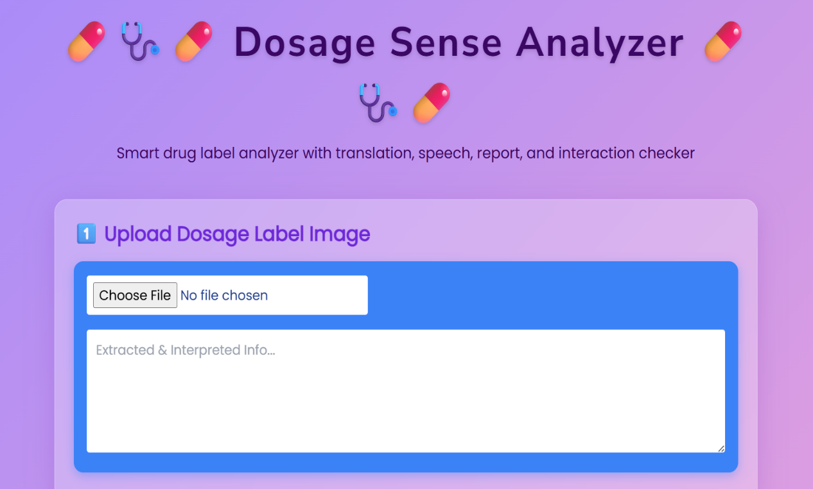

**Figure 9.1: USER INTERFACE FOR UPLOADING IMAGE**

The figure 9.1 shows that the user interface for uploading the image which will give you the details of the drug and the dose of it. So that there will be no risk in taking the drug what has suggest by doctor.

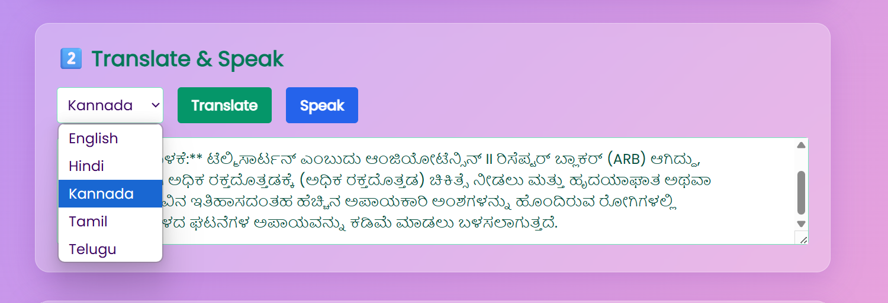

**Figure 9.2: LANGUAGE SELECTION**

The figure 9.2 shows that the user has to select the preferred language and click the translate button and wait for it to convert then user can click on the speak button.

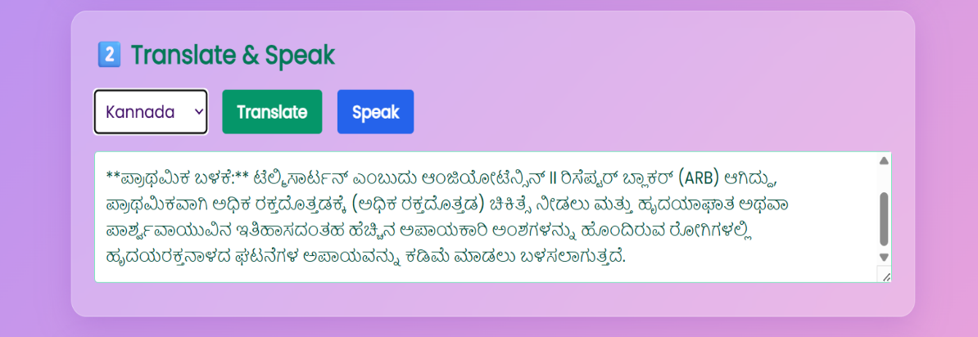

**Figure 9.3: KANNADA LANGUAGE TRANSLATION**

The figure 9.3 shows that the Kannada language translation of the drug where you will be going to get the details of the drug in user preferred language then click the translate button and it will change the text language and click on speak button.

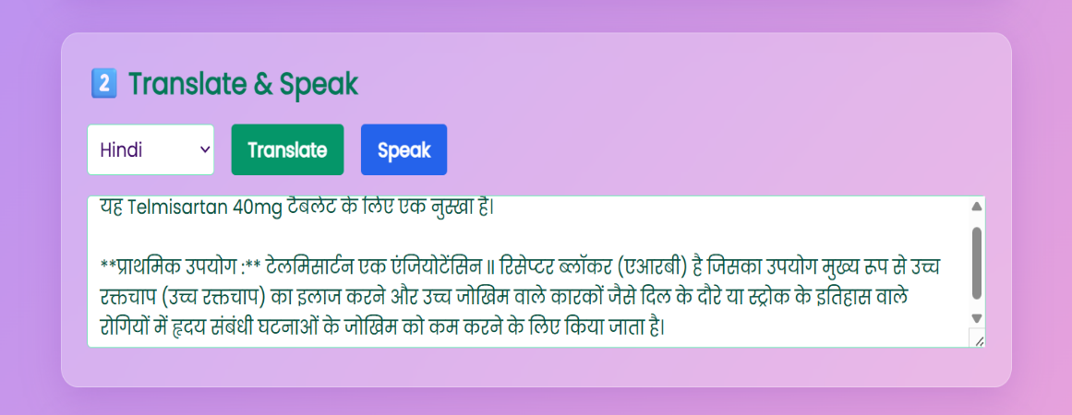

**Figure 9.4: HINDI LANGUAGE**

The figure 9.4 shows that the Hindi language translation of the drug where you will be going to get the details of the drug in user preferred language then click the translate button and it will change the text language and click on speak button.

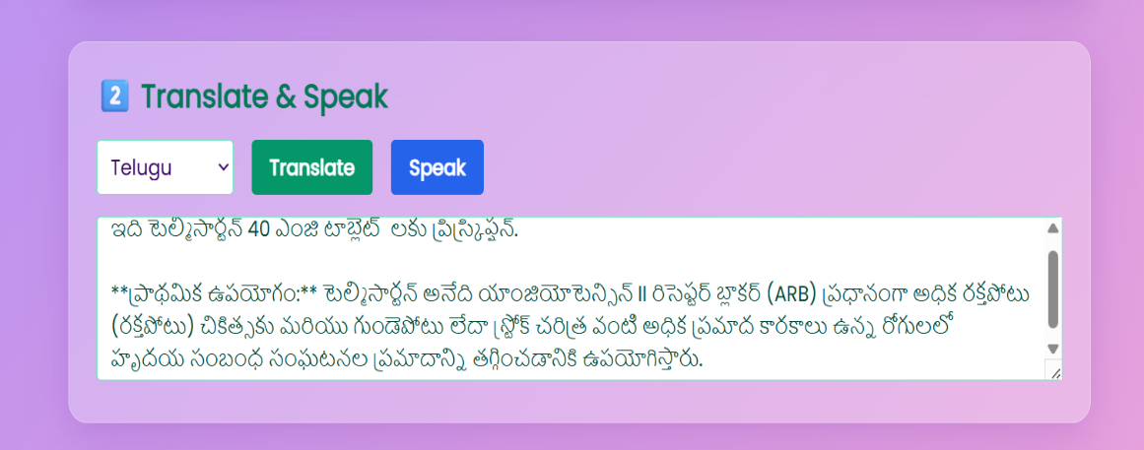

**Figure 9.5: TELUGU LANGUAGE**

The figure 9.5 shows that the Telugu language translation of the drug where you will be going to get the details of the drug in user preferred language then click the translate button and it will change the text language and click on speak button.

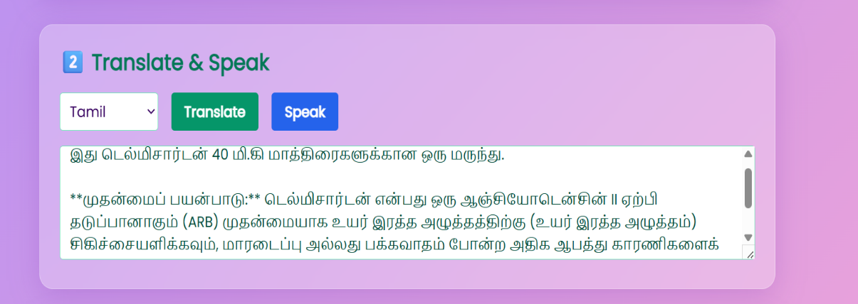

**Figure 9.6: TAMIL LANGUAGE**

The figure 9.6 shows that the Tamil language translation of the drug where you will be going to get the details of the drug in user preferred language then click the translate button and it will change the text language and click on speak button.

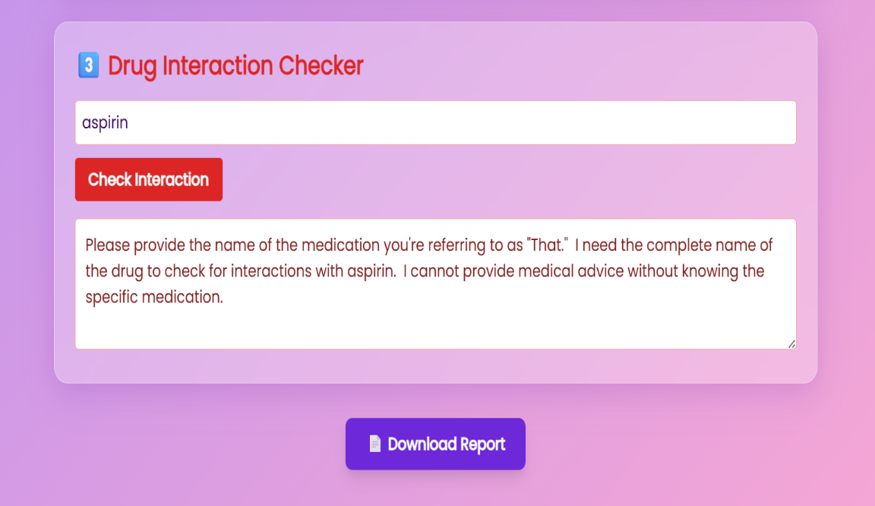

**Figure 9.7: DRUG INTERACTION CHECKER**

The figure 9.7 shows that the drug interaction checker where user can check the drug along with warning and chemical present in the drug.

# **CONCLUSION & FUTURE SCOPE**

## **CONCLUSION**

The "A Dosage Label Analyzer" successfully addresses challenges in reading drug labels by combining image processing, OCR, NLP, and TTS technologies. The application enhances accessibility and safety for users with reading or vision impairments. The application effectively addresses challenges in reading drug labels by extracting and vocalizing essential information through image and text processing. Image processing and OCR accurately capture text from labels, while NLP techniques ensure clear and organized information extraction. Text- to-Speech functionality provides audible drug information, enhancing accessibility for users with visual or literacy challenges. Experimental results show the method's reliability for standard labels, though image quality remains a factor for optimal accuracy. Overall, this solution improves safe drug usage and accessibility, especially for individuals who struggle to read traditional drug labels.

## **FUTURE SCOPE**

* Expand multilingual support to additional languages.
* Incorporate AI for better image correction and label extraction.
* Develop offline capabilities for areas with limited internet connectivity.
* Add features for user feedback and error reporting.